Answer 1) The method calculateTax() in the provided TaxUtil class is not a pure function because it is not satisfying Deterministic condition i.e. The same input always produces the same output.

It can be made pure by passing rate as a parameter.

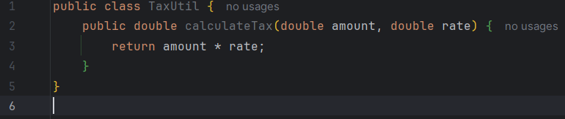

Answer 2) Output will be:-

super class show method

sub class show method

Because the code calls a static method from the outer class and an instance method from a static nested class, producing two separate outputs.

Answer 3) Output will be:-

display method

display method

10

10

This is because the child class method overrides the parent’s, and this.num accesses the child’s variable, printing the overridden method twice and value 10 twice.

Answer 4) Singleton Design Pattern restricts the instantiation of a class and ensures that only one instance of the class can be created.

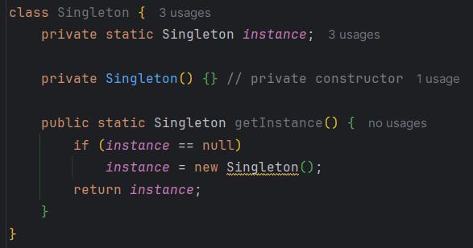

Answer 5) Encapsulation means hiding the internal details of a class and allowing access only through public methods (getters and setters). This ensures controlled access and protects data.

How to ensure a class is encapsulated:

* Make all data members private.
* Provide public getter and setter methods to access and modify the private variables.

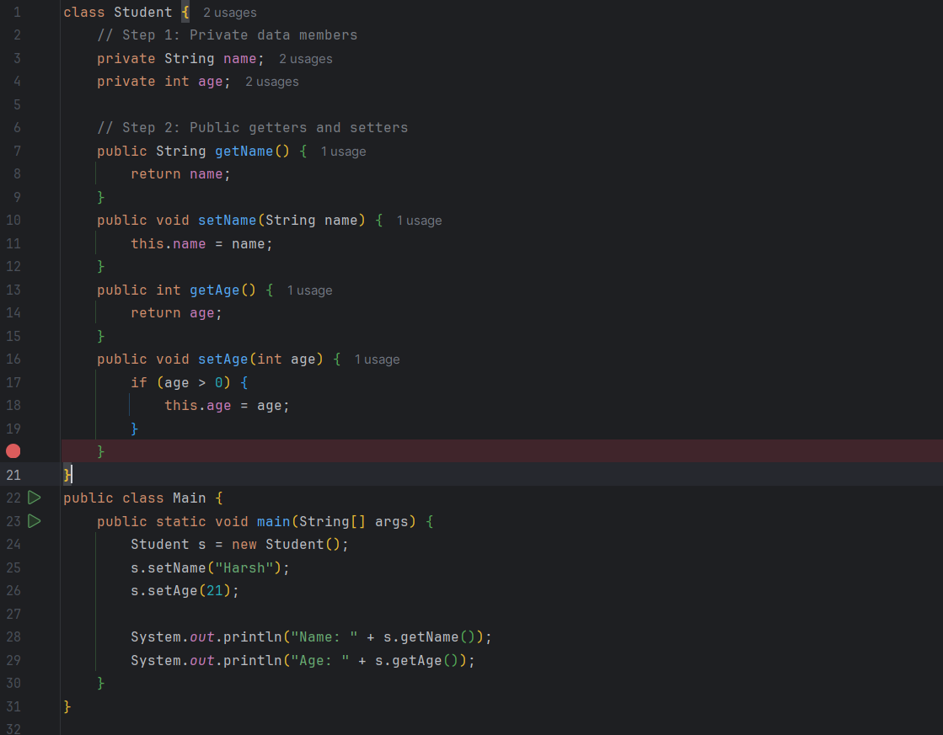



Answer 6)

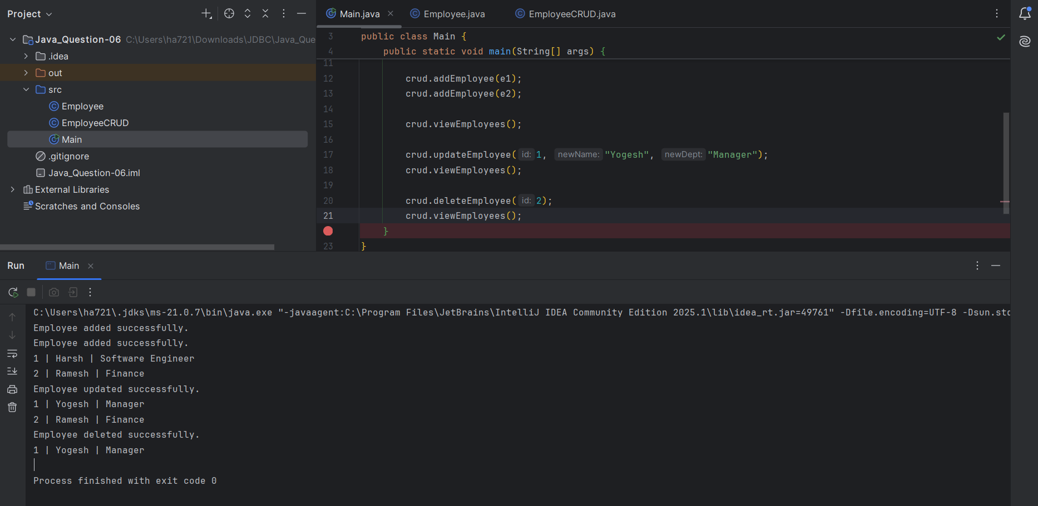

( <https://github.com/harsharora1710/rg-assignments/tree/feature-java> )

Answer 7)

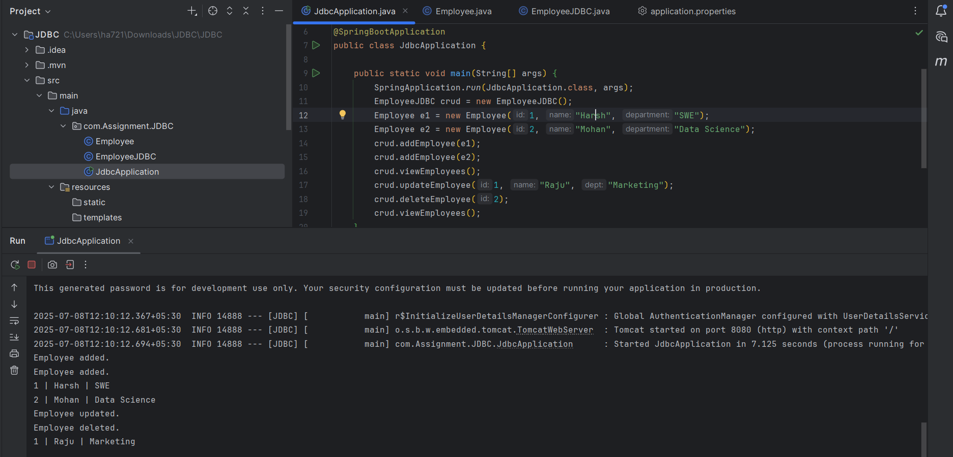

( <https://github.com/harsharora1710/rg-assignments/tree/feature-java> )